# Tableau Project Week -

## Day 1, Data Job Postings

Tableau project week will be a little different than others. Instead of one project for an entire week, we’ll be doing one project per day. Each day, we’ll give you a dataset, and your goal each day will be to create a series of visualizations and dashboards that help you understand the data. At the end of the week you will have four more dashboards for your portfolio.

| Monday | Tuesday | Wednesday | Thursday | Friday |
| --- | --- | --- | --- | --- |
| Project 1 | Project 2 | Project 3 | Project 4 | Presentations |

Each day (except Friday), the agenda will be roughly as follows

* 9AM: Attendance, morning discussion, assignment, meet with advisory groups
* 10AM: Exploratory Data Analysis
* 1PM: Visualizations, dashboards
* 3PM: Meet with your advisory group, show and tell.

On Friday afternoon, we will meet in groups and you will give a 10-minute presentation on your ‘favorite’ analysis from this week. You will work as individuals on these projects, but feel free to help each other.

# Data Job Postings

Data Job Listings.xlsx contains recent job postings for data analysts, data engineers, and data scientists. There are three worksheets which are structured the same, so you can make a union from the three worksheets to create a single dataset

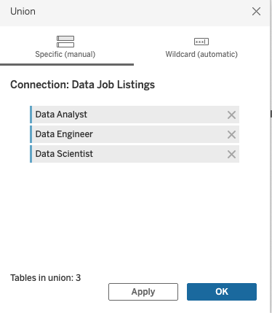

Each data set contains a job title, company name, location, a salary range (low and high), and a company rating, as well as many other dimensions. You will notice that NULL fields are sometimes identified with a -1 designation, so filters or aliases might be needed. Links to the original datasets on Kaggle are here:

[**Data Scientist Jobs**](https://www.kaggle.com/datasets/andrewmvd/data-scientist-jobs)

[**Business Analyst Job Listings**](https://www.kaggle.com/datasets/andrewmvd/business-analyst-jobs)

[**Data Engineer Jobs**](https://www.kaggle.com/datasets/andrewmvd/data-engineer-jobs)

Data transformations you might want to try during your EDA::

* Create groups for geographic regions, business types, industry, or sector
* Look for keywords in job descriptions using calculated fields
* Calculate midpoint of salary range
* Create sets for government vs non-government jobs.

Begin by asking questions, and creating visualizations to answer them. For instance, which cities have the highest minimum salaries? Do large companies pay better than small companies? You can bring additional data into your analysis, but be cautious; you don’t want to create more work than can be accomplished in 6 hours.

Some general advice:

* Imagine a user for your dashboard (i.e. a job hunter looking for insight)
* Ask “is this information useful?” to your user
* Don’t fixate or get stuck on one detail
* Don’t fall into analysis paralysis
* Manager your time
* Look for similarities and differences between categories (dimensions)
* Look for outliers (e.g. the best job, the worst job)

We look forward to seeing your results at 3pm! Here are your groups for ***Monday only***:

| **Monica** | **Vadim** | **Dennis** |
| --- | --- | --- |
| Shaday Brown | Chhaya Penn | Aaron Potts |
| Virna Brown | Brenda Jerez | Kristian McCombs |
| Daphney Oliveira | Chrissy Taylor | Ali Ashfaq |
| Marcus Madison | Victor Mantilla Colon | Rosana Infante |
| Chad Crossman | Sol-Marie Quintero | Marianna Beaute |
| Timothy Yip | Ess Guernah | Diana Ospina |
| Angelica Vera | Rosemary Espinal | Adam Shabana |
|  | Kosta Louvros |  |

## 